- Introduction to Client-Server Architecture.

Theory:

• Overview of client-server architecture.

Ans:-

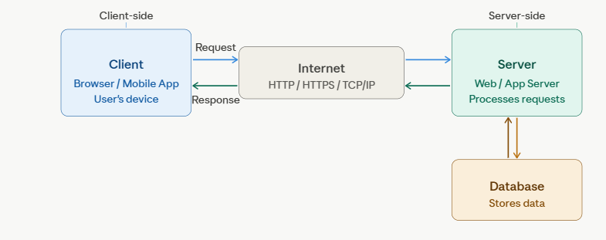

• Difference between client-side and server-side processing.

Ans :

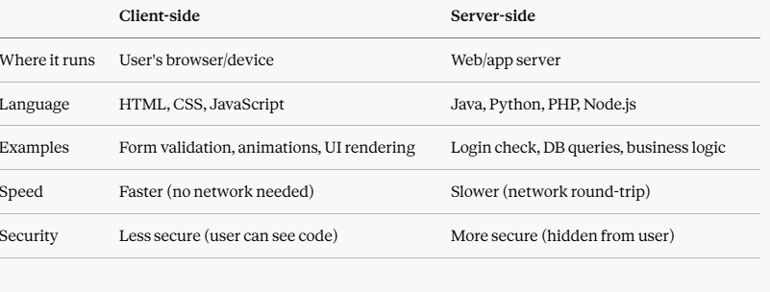

• Roles of a client, server, and communication protocols.

Ans:-
Client — sends requests, displays responses, handles UI interaction. Examples: browser, mobile app, desktop app.
Server — receives requests, runs business logic, queries the database, and sends back a response. Examples: Apache, Tomcat, Node.js server.
Communication Protocols — rules that define how data is sent and received:
- HTTP/HTTPS — transfers web pages and data (HTTPS is encrypted)
- TCP/IP — ensures data packets are delivered reliably
- DNS — translates domain names (google.com) to IP addresses
- FTP — transfers files between client and server

- HTTP Protocol Overview with Request and Response Headers

Theory:
• Introduction to the HTTP protocol and its role in web communication.
Ans:-
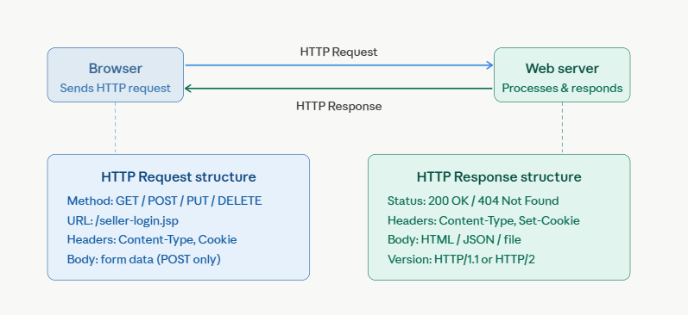

• Explanation of HTTP request and response headers

Ans:-
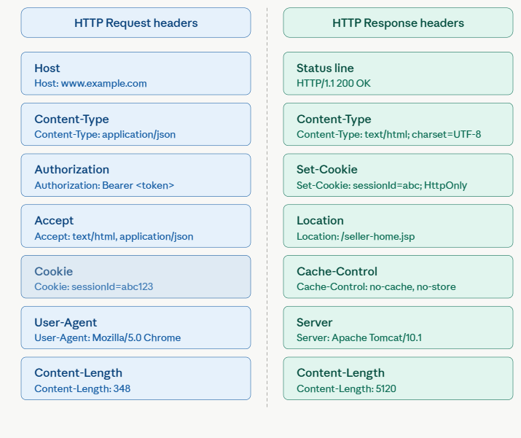

- J2EE Architecture Overview

Theory:
• Introduction to J2EE and its multi-tier architecture.
Ans:-
J2EE (Java 2 Platform, Enterprise Edition), now called Jakarta EE, is a set of specifications and APIs for building large-scale, multi-tier, distributed enterprise applications in Java. It provides a standard platform so developers don't have to build everything from scratch.
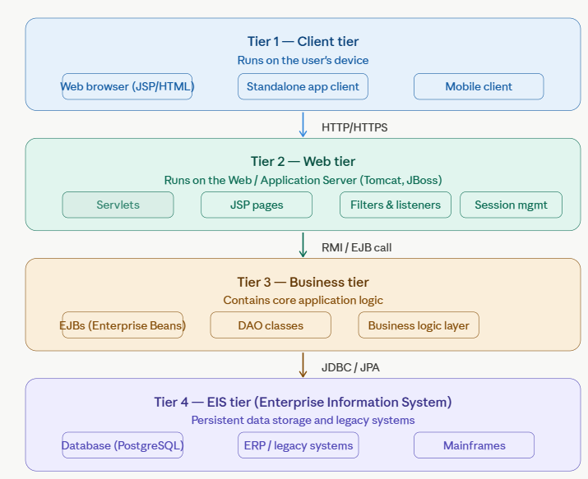
• Role of web containers, application servers, and database servers

Ans:-
A web container (also called a servlet container) is software that manages the lifecycle of Servlets and JSP pages. It is the runtime environment where your Java web code actually executes.
An application server is a superset of a web container. It includes everything a web container has, plus full J2EE enterprise services.
A database server is dedicated software that stores, retrieves, and manages structured data. The application server communicates with it using JDBC (Java Database Connectivity) or JPA.

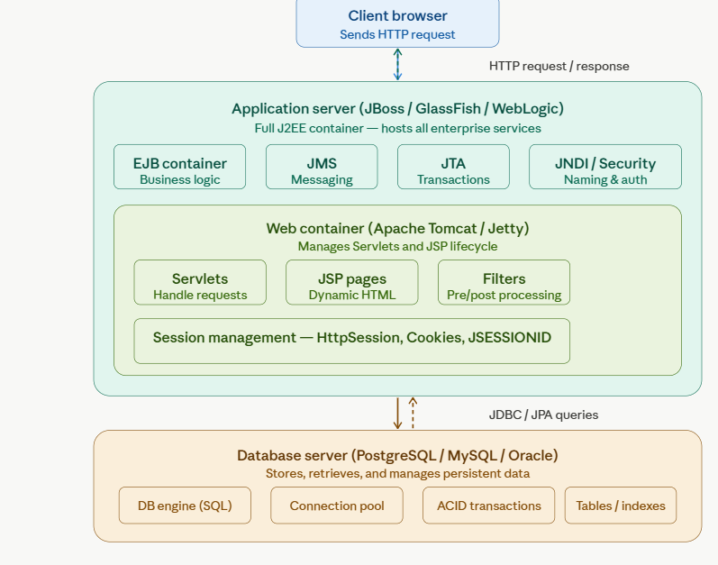

- Web Component Development in Java (CGI Programming)
Theory:
• Introduction to CGI (Common Gateway Interface).
Ans:-
CGI (Common Gateway Interface) is the oldest standard for making web pages dynamic. Before CGI, web servers could only serve static HTML files. CGI allowed a web server to execute an external program and return its output as an HTTP response.

• Process, advantages, and disadvantages of CGI programming.

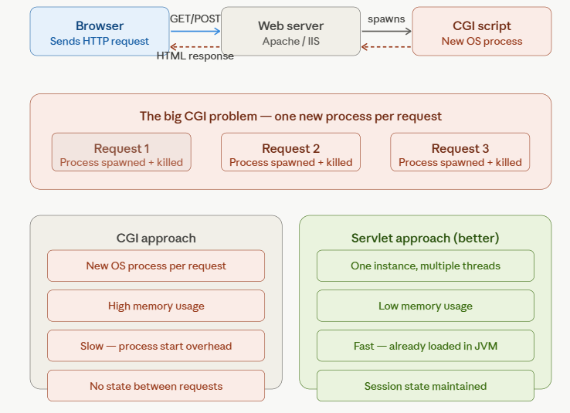

- Servlet Programming: Introduction, Advantages, and Disadvantages.
Theory:
• Introduction to servlets and how they work.

Ans:-
A Servlet is a Java class that runs inside a web container (like Tomcat) and handles HTTP requests and responses. It is the Java replacement for CGI — faster, more efficient, and reusable. Every time a user submits a form or visits a URL in your Java web app, a Servlet is the code that receives it, processes it, and decides what to send back.

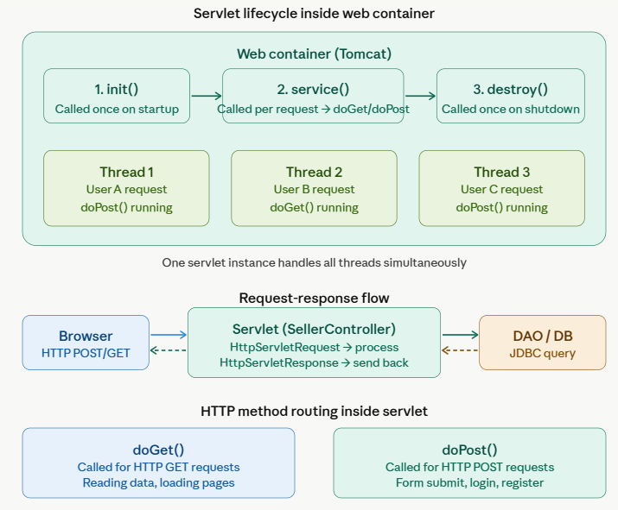
• Advantages and disadvantages compared to other web technologies.
Ans :-
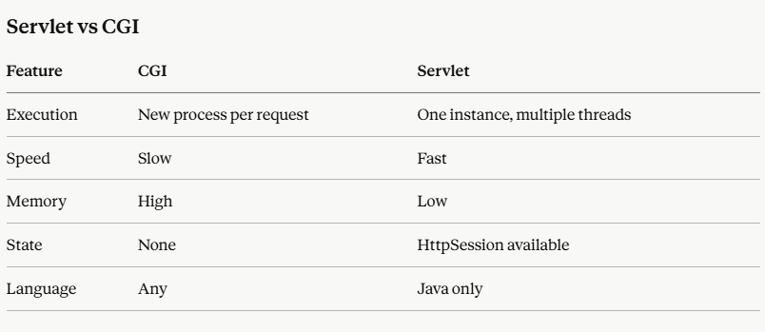

- Servlet Versions, Types of Servlets.
- Difference between HTTP Servlet and Generic Servlet
Theory:
• Types of servlets: Generic and HTTP servlets
Ans :-
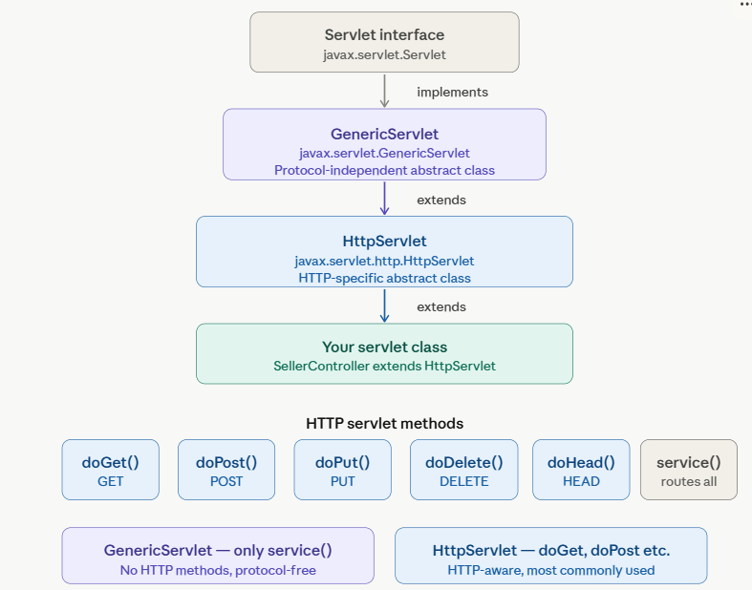

- Servlet Life Cycle
Theory:
• Explanation of the servlet life cycle: init(), service(), and destroy() methods.
Ans:-
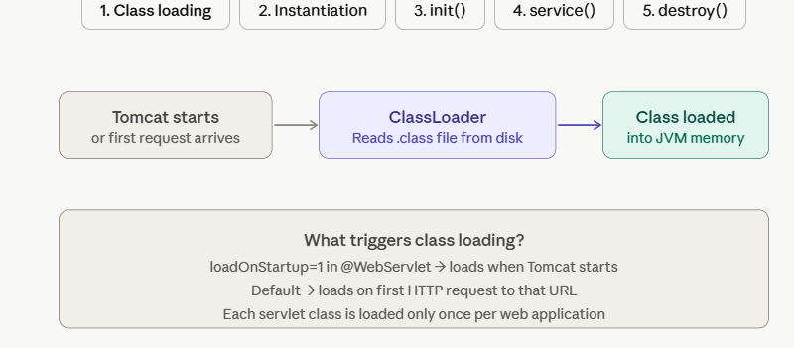

- Creating Servlets and Servlet Entry in web.xml.
Theory:
• How to create servlets and configure them using web.xml.
Ans:-
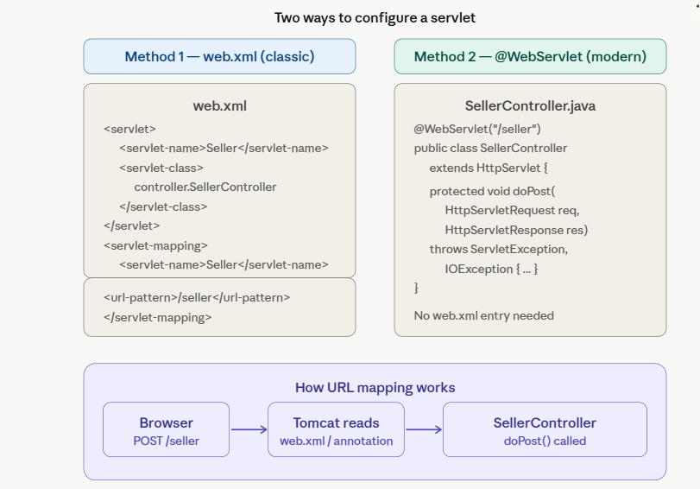

- Logical URL and ServletConfig Interface
Theory:
• Explanation of logical URLs and their use in servlets.
Ans:- A URL (Uniform Resource Locator) identifies a resource on the web. In the context of Java Servlets, URLs are used to map HTTP requests to specific servlet classes.
A logical URL is simply the alias or friendly name you assign to a servlet — it hides the internal implementation details from the client.
Ways to Define Logical URL Mappings
Using web.xml (Deployment Descriptor)
Using @WebServlet Annotation (Servlet 3.0+)
• Overview of Servlet Config and its methods.
Ans:-

- Request Dispatcher Interface
Theory:
• Explanation of Request Dispatcher and the forward() and include() methods.
Ans:- RequestDispatcher is an interface in javax.servlet package that allows a servlet to forward or include the content of another resource (servlet, JSP, or HTML file) within the same web application.
- Obtained from ServletRequest or ServletContext
- Used for server-side navigation (URL does NOT change in browser)
- Enables modular web design by combining multiple resources.
Two Core Methods
forward(request, response):-Transfers control completely to another resource
include(request, response):-Includes output of another resource in current response.

- ServletContext Interface and Web Application Listener
Theory:
• Introduction to ServletContext and its scope.

Ans:- ServletContext is an interface in javax.servlet package that represents the entire web application and provides a way for servlets to communicate with the servlet container.
- Created by the Servlet Container at application startup
- One ServletContext object exists per web application
- Shared across all servlets in the application
- Destroyed when the application is stopped or undeployed
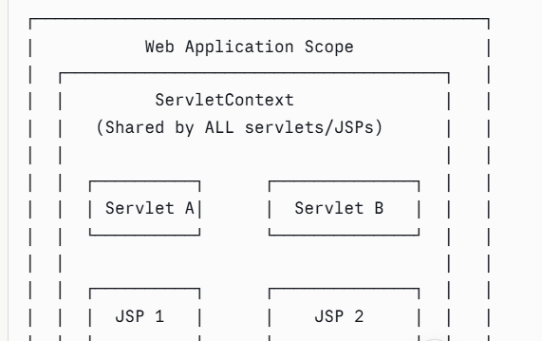

• How to use web application listeners for lifecycle events.
Ans:- Web Application Listeners are special Java classes that monitor and respond to lifecycle events occurring in a web application — such as the application starting/stopping, sessions being created/destroyed, or attributes being added/removed.
- Implement specific listener interfaces from javax.servlet package
- Registered via web.xml or @WebListener annotation
- Automatically invoked by the Servlet Container when events occur
- Follow the Observer / Event-Driven design pattern

- Java Filters: Introduction and Filter Life Cycle.
Theory:

• What are filters in Java and when are they needed?
Ans:- A Filter is a Java class that intercepts HTTP requests and responses before they reach a servlet and after the servlet sends a response. It sits in the middle of the request-response pipeline, allowing you to inspect, modify, or block traffic without touching servlet code.
- Implements the javax.servlet.Filter interface
- Registered via web.xml or the @WebFilter annotation
- Can be chained — multiple filters execute in sequence
- Follows the Chain of Responsibility design pattern
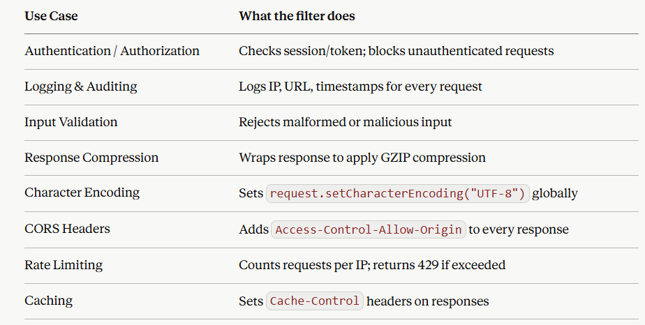
• Filter lifecycle and how to configure them in web.xml
Ans:-
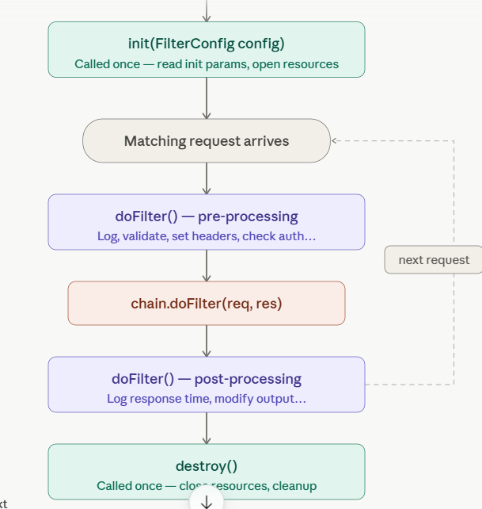

- JSP Basics: JSTL, Custom Tags, Scriplets, and Implicit Objects.

Theory:
• Introduction to JSP and its key components: JSTL, custom tags, scriplets, and implicit objects.
Ans:- Java Server Pages (JSP) is a server-side technology that lets you embed Java code directly inside HTML to create dynamic web pages. The servlet container compiles each .jsp file into a servlet behind the scenes — JSP is essentially a friendlier way to write presentation logic without building a full servlet class.
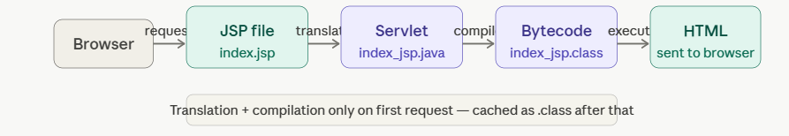

JSP Page Directives
Directives configure the page itself — they don't produce output; they instruct the container.
1. Scriptlets
Scriptlets embed raw Java code directly inside a JSP page using <% %> delimiters.
2. Implicit Objects
The container pre-creates nine objects that are available in every JSP page without any declaration. They are the JSP equivalent of the objects you'd manually obtain in a servlet.
3. JSTL — JSP Standard Tag Library
JSTL replaces scriptlets with clean, readable XML-style tags. It has five tag libraries:
4. Expression Language (EL)
EL — the ${ } syntax — lets you access beans, scoped attributes, and collections without a single line of Java.
5. Custom Tags
Custom tags let you package reusable logic into your own XML-style tags — the same idea as JSTL, but built by you.
There are two parts: a Tag Handler class and a Tag Library Descriptor (TLD) file.

- Session Management and Cookies.
Theory:
• Overview of session management techniques: cookies, hidden form fields, URL rewriting, and sessions.
Ans :- Session Management Techniques in Web Development
Session management allows web applications to maintain stateful information across multiple HTTP requests — necessary because HTTP is a stateless protocol.
Hidden Form Fields
Session data is embedded in HTML forms as <input type="hidden"> and submitted with form posts.
How it works:
- Server embeds state/identifiers in every HTML form
- Data is sent back when the user submits the form
URL Rewriting
Session identifiers are appended to every URL as a query parameter.
How it works:
- Server dynamically rewrites all links on the page to include the session ID
- The ID is extracted from the URL on each request
Server-Side Sessions
The most common modern approach — a session token (usually stored in a cookie) maps to session data stored on the server.

• How to track user sessions in web applications

Ans:-
